A report on Software Development Companies in Kolkata

This report analyzes Kolkata-based competitors across these domains. Source: Clutch.co , Goodfirms, Individual Company Websites. The analysis covers Industry Distributions, Client Networks, Opportunity Matrices, Radar Chart positioning, and Priority Actions.

INDUSTRY DISTRIBUTIONS BY DOMAIN

- AI Solutions Industry Distribution

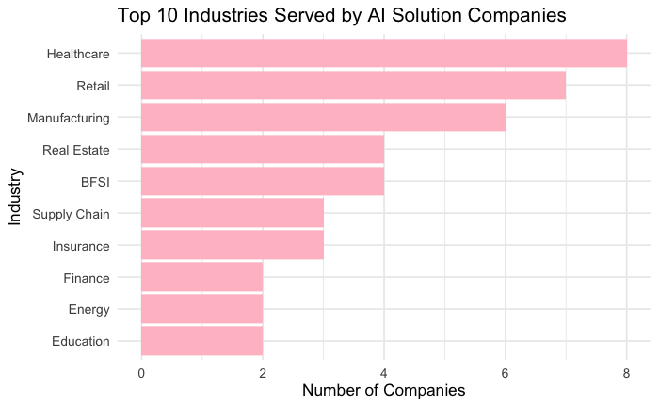

Top Industries Targeted: Healthcare, Retail, Manufacturing, Real Estate, BFSI, Supply Chain, Insurance, Finance, Energy, Education.

Healthcare is the most saturated industry for AI solutions. Retail and Manufacturing also show high competition.

The least crowded industries are Education and Energy. These have the fewest competitors but show growing demand for AI adoption.

- App Development Industry Distribution

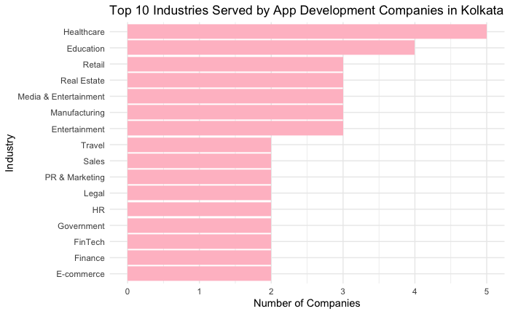

Top Industries Targeted: Healthcare, Education, Retail, Real Estate, Media & Entertainment, Manufacturing, Travel, FinTech, Finance, eCommerce.

App development is heavily saturated in Healthcare, Education, and Retail. Real Estate and Manufacturing sit in the middle.

The best opportunities lie in Government, Legal, HR, PR & Marketing, and Sales as these industries have the fewest competitors.

- Digital Marketing Industry Distribution

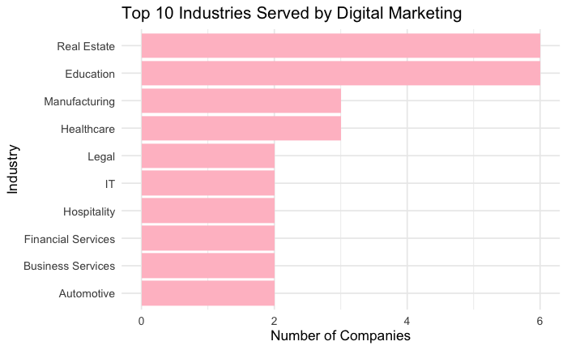

Top Industries Targeted: Real Estate, Education, Manufacturing, Healthcare, Legal, IT, Hospitality, Financial Services, Business Services, Automotive.

Real Estate and Education show the highest number of companies targeting them.

The least crowded industries are Automotive and Business Services. These have potential for specialized digital marketing focus.

- Digital Transformation Industry Distribution

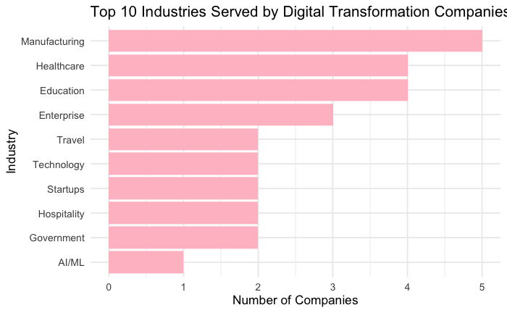

Top Industries Targeted: Manufacturing, Healthcare, Education, Enterprise, Travel, Technology, Startups, Hospitality, Government, AI/ML.

Manufacturing leads with the highest number of companies.

The least crowded segments are AI/ML and Government. These niches have low competition but increasing transformation needs.

- SEO Industry Distribution

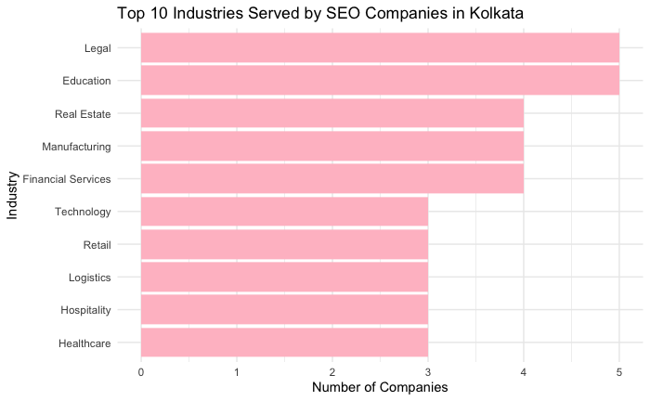

Top Industries Targeted: Legal, Education, Real Estate, Manufacturing, Financial Services, Technology, Retail, Logistics, Hospitality, Healthcare.

Legal services have the highest concentration of SEO companies.

The least crowded industries are Healthcare and Hospitality. These show opportunity for SEO specialization.

- Web Development Industry Distribution

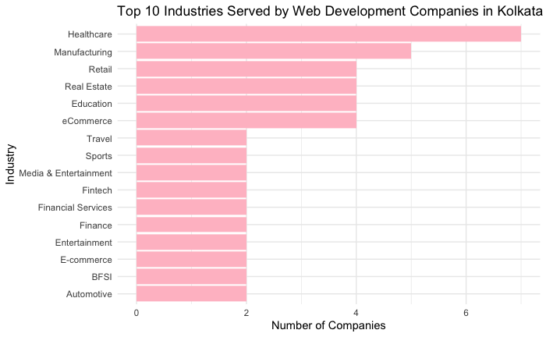

Top Industries Targeted: Healthcare, Manufacturing, Retail, Real Estate, Education, eCommerce, Travel, Sports, Media & Entertainment, FinTech.

Healthcare leads web development demand. Manufacturing and Retail follow.

The least crowded industries are Sports and Media & Entertainment. These niches have fewer competitors.

CLIENT NETWORKS BY DOMAIN

- AI Solutions Client Network :

Adidas, SBI Global, American Auto Club, Aditya Birla Health, AIA Hong Kong, DreamzTech Solutions, Indus Net Technologies, Innovacio Technologies, Mantra Labs, Pitangent Analytics, TCG Digital. Key Takeaway: AI competitors serve major brands across healthcare, insurance, and retail. Enterprise clients dominate this space.

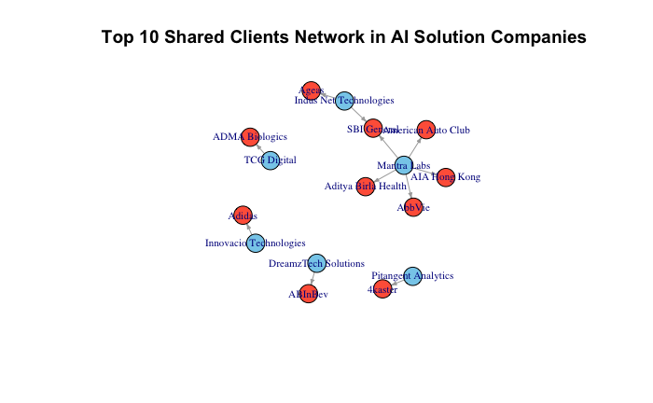

- App Development Client Network:

Boston Red Sox, Big Ten Conference, Chord Sheet Pro, Digital Aptech, Bernard Industrial Services, DiaMin Group LLC, Shyam Future Tech Pvt. Ltd., Bubblegum Consulting Service, Connect A Load LLC, Weavers Web Solutions Pvt. Ltd. Key Takeaway: App development competitors serve sports, manufacturing, and consulting clients. Mid-market clients are common.

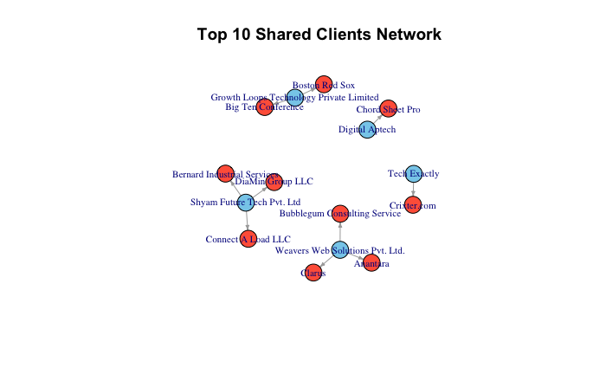

- Digital Marketing Client Network:

Amazon, Bergevin & Maching, Blue Dart, Techno Exponent, Logic Square Technologies, Business Process Software Firm, Lee and Nee, Business Midwife Marketing Agency. Key Takeaway: Competitors serve e-commerce giants and business service firms. Local and national brands appear.
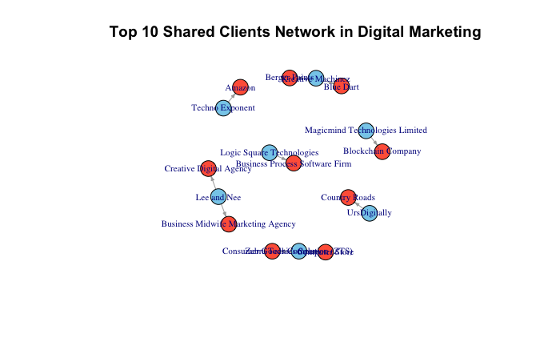

- Digital Transformation Client Network:

Conde Nast, Capital Nominees, Amount, Cinepolis, Nestle, DreamzTech Solutions, Alumine Brothers Brewery Rentals, Digital Aptech, PiTangent Analytics, Care App, CelticCK Productions, Designs Codes. Key Takeaway: Digital transformation clients include media, manufacturing, and publishing enterprises. Fortune-level clients are present.

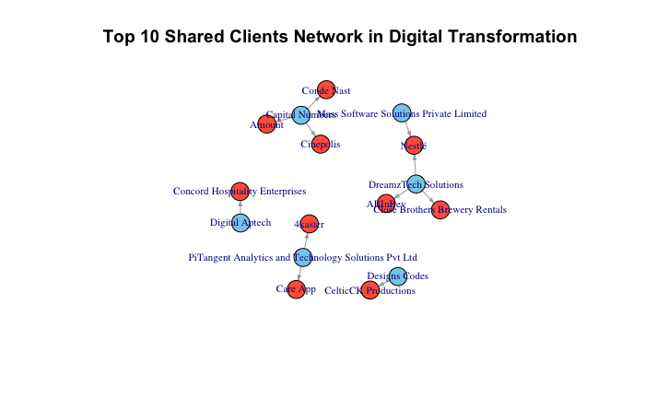

- SEO Client Network:

Carney Technologies Services, Zebra Technologies Solution (ZTS), Business Midwife Marketing Agency, Lee and Nee, Creative Digital Agency, Magicmind Technologies Limited, Blockchain Company, Logic Square Technologies, Business Process Software Firm, The Clueless Company, Techwishes Solutions, As It Is Nutrition, WebHosting Services, BAIM Ltd. Key Takeaway: SEO clients span legal, technology, and business services. Small to mid-size businesses dominate.

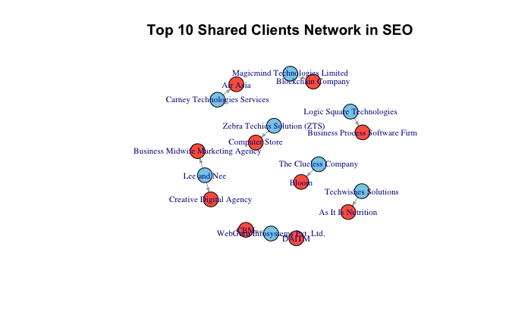

- Web Development Client Network:

CelticCHP, Analytics and Technology Solutions Pvt Ltd, 4kaster, Concord Hospitality Enterprises, Digital Aptech, Mass Software Solutions, Cinepolis, DreamzTech Solutions, Close Brothers Brewery Rentals, AllInDev, Cordapt Solutions, Amount. Key Takeaway: Web development clients include hospitality, manufacturing, and entertainment. Enterprise and mid-market mix.

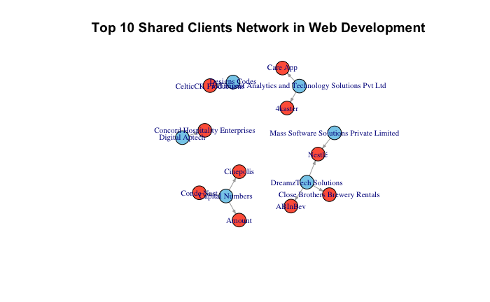

OPPORTUNITY MATRICES BY DOMAIN

Each matrix shows Competition Density (X-axis) vs Market Demand (Y-axis). Target opportunities with HIGH demand and LOW competition.

- AI Solutions Opportunity Matrix:

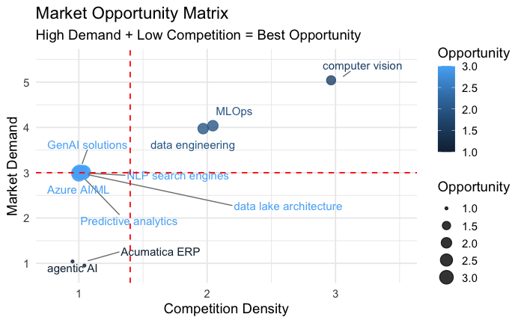

Prime Targets (High Demand, Low Competition) include Agentic AI, Predictive analytics, Data lake architecture, NLP search engines, GenAI solutions, and Automata ERP. Avoid Basic AI/ML services and legacy automation which have high competition.

- App Development Opportunity Matrix:

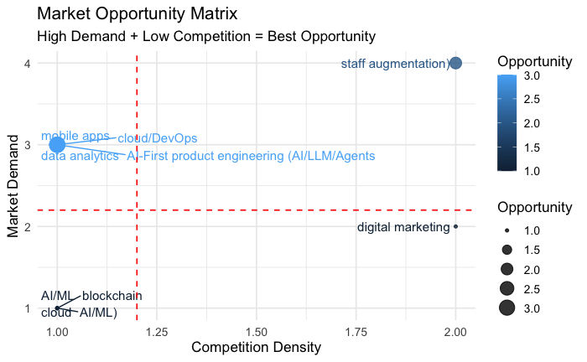

Prime Targets include AI-First product engineering (AI/LLM/Agents), Staff augmentation, and Data analytics. Avoid Standard mobile apps and basic web development which have high competition.

- Digital Marketing Opportunity Matrix:

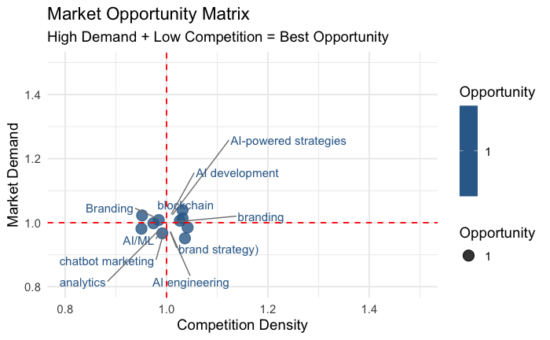

Prime Targets include AI-powered strategies, AI development integration, Chatbot marketing, Brand strategy, Analytics and AI engineering. Avoid Basic SEO and generic social media management which have high competition.

- Digital Transformation Opportunity Matrix:

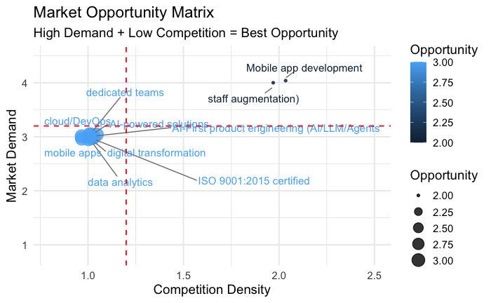

Prime Targets include AI-powered software product engineering, Cloud/DevOps transformation, Data analytics, Dedicated teams, Staff augmentation. Avoid Basic IT consulting and legacy migration which have high competition.

- Web Development Opportunity Matrix:

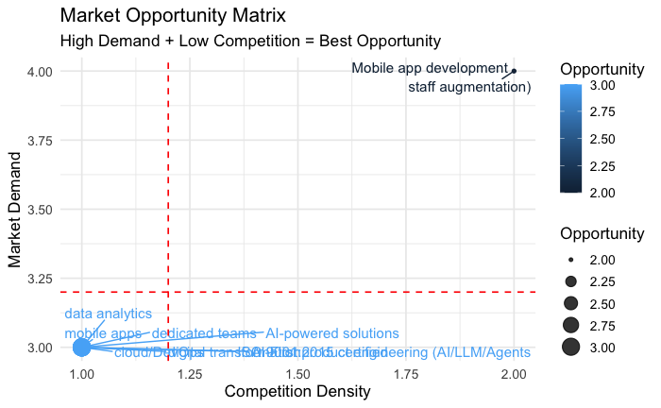

Prime Targets include Mobile app development, Staff augmentation, Data analytics, AI-powered solutions, Cloud/digital transformation, Dedicated teams. Avoid Basic website development and generic CMS work which have high competition.

FINAL STRATEGIC RECOMMENDATION FROM INDUSTRY ANALYSIS

IT/Software and eCommerce are overcrowded across ALL service lines – avoid them as primary targets in Kolkata.

The best opportunities for eBluesoft are: Real Estate (appears across AI Solutions, App Development, Digital Marketing, SEO, and Web Development as high-demand, moderate-to-low competition). Education (strong across App Development, Digital Marketing, Digital Transformation, SEO, and Web Development with lower competition). Healthcare (consistent demand across AI Solutions, App Development, Digital Marketing, Digital Transformation, SEO, and Web Development). Manufacturing (appears in AI Solutions, App Development, Digital Transformation, SEO, and Web Development with lower competition). Logistics & Supply Chain (niche opportunity in AI Solutions and Web Development). Sports (low-competition niche in App Development and Web Development).

Focus sales efforts on Real Estate, Education, and Healthcare to avoid the crowded IT/eCommerce space in Kolkata.

POSITIONING REPORT: EBLUESOFT VS TOP 3 KOLKATA COMPETITORS

Based on the radar chart analysis (scores from 0 to 5 across 7 parameters)

TOP 3 COMPETITORS IDENTIFIED

The analysis ranks these three companies as the strongest in Kolkata across all parameters: Webskitters, Indus Net Technologies, Unified Infotech. These three companies form the benchmark. They are the ones eBluesoft needs to catch up to.

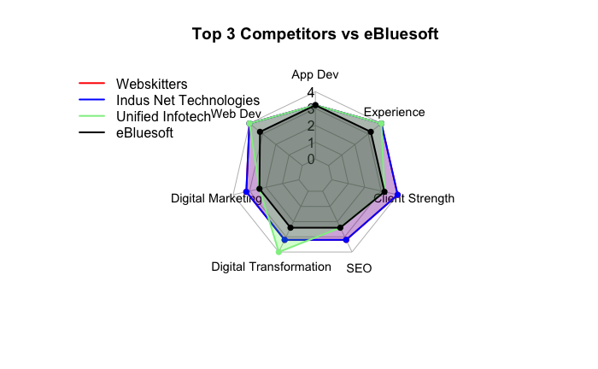

The radar chart shows seven parameters: App Dev, Web Dev, Digital Marketing, Digital Transformation, SEO, Client Strength, Experience. Webskitters shows the largest coverage area, meaning it leads across most parameters. Indus Net Technologies and Unified Infotech follow closely. eBluesofts coverage area is visibly smaller, especially in three parameters: Digital Transformation, Client Strength, and Experience.

WHERE EBLUESOFT IS COMPETITIVE (Scores close to competitors): App Dev score is close to Unified Infotech. Small gap. Web Dev score is moderate. Gap exists but not critical. SEO score is competitive. This is a relative strength. Digital Marketing score is moderate. Room for improvement but not the biggest gap.

WHERE EBLUESOFT IS WEAK (Largest gaps): Digital Transformation is the biggest visible gap on the radar chart. Webskitters and Indus Net Technologies lead here. eBluesoft is far behind. Client Strength is also a major gap. Top competitors have strong client lists and case studies. eBluesoft lacks visible credibility. Experience gap is moderate but matters for enterprise clients.

The top competitors are not strong in just one area. They are strong across all seven parameters simultaneously. Webskitters leads in Digital Transformation and Client Strength. This is their clear differentiator. Indus Net Technologies leads in App Dev and Web Dev with balanced scores across all parameters. Unified Infotech is competitive across the board but not the absolute leader in any single parameter. eBluesofts shape is uneven. Strength in SEO and App Dev, but weak in Digital Transformation and Client Strength. This uneven profile makes eBluesoft vulnerable in competitive bids where clients expect balanced capabilities.

PRIORITY ACTIONS

Priority 1: Add AI and Digital Transformation services to website - AI-powered chatbots, automation workflows, predictive analytics, AI content generation tools, cloud migration consulting, legacy system modernization. Create an AI Solutions service page and a Digital Transformation service page on the eBluesoft website. Train existing team on AI tools and transformation frameworks or hire one AI specialist and one transformation consultant.

Priority 2: Collect 5 to 10 video testimonials from existing happy clients. Add client logos to the website homepage. Publish 3 detailed case studies focused on Real Estate, Healthcare, and Manufacturing. Get listed on Clutch.co with 10+ verified reviews.

Priority 3: Change positioning from generic to specific. Instead of Web Development Company in Kolkata, use Real Estate Digital Solutions Provider or Healthcare SEO and Marketing Agency. Create two industry-specific landing pages on the website: Real Estate Digital Solutions and Healthcare SEO and Marketing. Train sales team to lead with Real Estate and Healthcare, not generic IT.

Priority 4: Create a professional pitch deck template. Standardize all client deliverables with branded templates. Get listed on Clutch, Goodfirms etc.**. Also have a good social media presence and promote the company with the newest trends.

Priority 5: Stop targeting IT/Software and eCommerce as primary industries. They are overcrowded across all service lines. Start targeting Real Estate (appears across AI, App Dev, Digital Marketing, SEO, and Web Development as high-demand, low-competition). Start targeting Education (strong across App Dev, Digital Marketing, Digital Transformation, SEO, and Web Development with lower competition). Start targeting Healthcare (consistent demand across AI, App Dev, Digital Marketing, Digital Transformation, SEO, and Web Development). Start targeting Manufacturing (appears in AI Solutions, App Development, Digital Transformation, SEO, and Web Development with lower competition).

COMPARISON WITH PREVIOUS NATIONAL ANALYSIS

The national analysis identified Dotsquares, TechAhead Corp, and Aubergine Solutions as top competitors. Those are national and global players. The Kolkata analysis identifies Webskitters, Indus Net Technologies, and Unified Infotech as local top competitors. This is good news. The Kolkata competitors are closer to eBluesofts size and scale than the national giants. The gaps are smaller and easier to close.

